DRAFT
LAS POSITAS COLLEGE
CLASSIFIED SENATE

JANUARY 28, 2010

2:30 P.M., ROOM 1603

MINUTES

Present: Cindy Balero, Rita Carson, Sharon Davidson, William Eddy, Sharon Gach, Natasha Lang, Carmen McCauley, Elizabeth Noyes, Karin Rose, Jeff Sperry, Todd Steffan, Heidi Ulrech, Christie Verarde

Guest: Jim Gioia

1. Welcome/Call to Order:

The meeting was called to order at 2:40 p.m. Quorum was met. Ms. Lang welcomed everyone and thanked them for taking the time to attend the meeting.

2. Introduction of New Attendees & New Staff:

No items.

3. Approval of Agenda and Minutes:
The agenda was approved unanimously.

Ms. Verarde motioned to approve the December 18, 2009 minutes as written; seconded by Ms. Rose. Motion carried with one abstention.

4. Budget:
Additional profits totaling $432.35 was collected.

Total social account balance is: $957.33
Training account balance is: $821.00
Additional Staff Development funds for Flex Day: $2,000.00

- Committee Reports:
  - January President’s Report: Refer to written report (attached)

  - Classified Senate Committees:
    - Activities Committee/Flex Day Plans (N. Lang/C. Balero): Several topics/themes have emerged:
- “Hidden Gems of LPC”
- TLC (formerly the Innovation Center)
- Facilities up and coming, tours, Mr. Kratochvil invited to speak.
- Budget discussion and open forum with Dr. Pollard
- Bocce ball (late afternoon)

The overall goal is to plan a day in which opportunities at all levels are made available. A subcommittee is still needed to work on coordination of events, etc. Mr. Eddy volunteered; however, additional support is still needed. Ms. Gach indicated she will send out an email soliciting interest and report back at the next meeting.

    - Sunshine Report (C. Reding/N. Lang): A card has been sent to Scott Vigallon and Ann Jones. A brief history of the fund and expenditure process was discussed.

    - Fundraising:
      - Candy Sales (C. Verarde): A candy box was purchased from Costco. It has been sold, totaling $24.00. Each candy bar is being sold for $1.00. Two (2) additional boxes will be purchased and located at Ms. Verarde’s desk. The goal is to sell $100.00 total.
      - Swap Meet for Staff/Students (W. Eddy): Approval is being sought for a location on campus to host the event. It will more than likely be held on a Friday. It will mirror the previous silent auction minus bidding. It is possible it will be held on a date after spring break. Volunteers are need and more information is to come. Contact William Eddy for more information. The possibility of including a BBQ was discussed.

- Old Business:
  - SEIU Update - None

  - Scholarships 2010 – How many $100 scholarships to award: A brief discussion occurred regarding the funding and amount of scholarships. Initially it was suggested six (6) be funded; however, everyone was reminded of the cost for the Outstanding Classified Award, which is approximately $300.00. Last year $500.00 was funded ($100 each). Ms. Lang noted she would like to confer with Ms. Shreibman regarding the criteria. It was noted Bookstore giftcards are appreciated by students. In conclusion it was determined the same amount as the previous year will be set aside for the scholarships. (5 at $100 each) due to the tight economic time/budget. It is hoped this can be increased in the future.

Ms. Ulrech motioned to approve five (5) $100 each Classified Senate Scholarship Gift Cards to the LPC Bookstore; seconded by Ms. Verarde. Motion passed unanimously.

    - Update on Strategic Visioning Process/Common Ground Subcommittee (Attachments #1, 2, 3): Dr. Gioia thanked classified staff for their participation in the process. He went on to explain the purpose of the Common Ground Subcommittee is to flesh out ideas for the strategic vision as well as dissect the original reporting relationships and diagram(s) presented. Key Performance Indicators (KPI’s) were highlighted and explained. Dr. Gioia reported the Common Ground Subcommittee recommends the March 12 Flex Day be used to “unpack” and work on refining the ten (10) goals in attempt to make them more tangible and measurable with KPI’s. The ultimate goal is to improve interaction and processes between all groups involved; as well as develop a consistent, common tool for resource allocation for all disciplines. In conclusion it was noted the Academic Senate is discussing its role in the planning of the Flex Day agenda in conjunction with Staff Development and Dr. Pollard. Ms. Lang thanked Dr. Gioa for his presentation and asked for a motion to approve the work done by the Common Ground Subcommittee.

Mr. Eddy motioned to approve the work of the Common Ground Subcommittee as discussed and presented today; seconded by Ms. Noyes. Motion carried unanimously.

  - Outstanding Classified of the Year – Revision and History: Sharon Gach reported she is working with Debbie Earney and will be distributing revisions shortly. Ms. Earney would like to move onto other projects. It was proposed it be given a more formal “permanent home” in the Bylaws; where the committee structure can be “tightened up” and ownership taken. Ms. Gach requested this be an agenda item at the next meeting.

- New Business
  - Opening for VP of Fundraising: Everyone was encouraged to solicit anyone interested in filling this position. Contact Ms. Lang for more information.

  - Bylaws Review and Discussion: Due to the nature of the discussion of this topic, it was requested it be moved to the February/March meeting so as to allow for more discussion time. One item for consideration for addition into the Bylaws is how language should be stated/constructed for new staff/new hires and IT staff moving here, since the college is growing. What reporting/funding mechanisms
should be included? It was noted the current language “assigned to” is intentionally vague. More clarification is needed; additionally, concerns were raised regarding voting; specifically regarding concise, clear language. Bargaining unit concerns should remain separate. Ms. Lang noted the Bylaws should be “inclusive of what we mean.” In closing, Ms. Ulrech commented on the historical drafting and re-drafting of the document, reminding all it is a tedious project to undertake to revise them.

8. Other
Everyone was reminded Granlibakken is coming up in June. We are eligible for three (3) spots. Anyone interested in attending will need to have the forms submitted by February 26th and let Ms. Lang or Ms. Gach know as soon as possible.

- Good of the Order
No items.

- Adjournment
The meeting adjourned at 4:20 P.M.

Recording Secretary: Carie Kincaid

Attachment #1

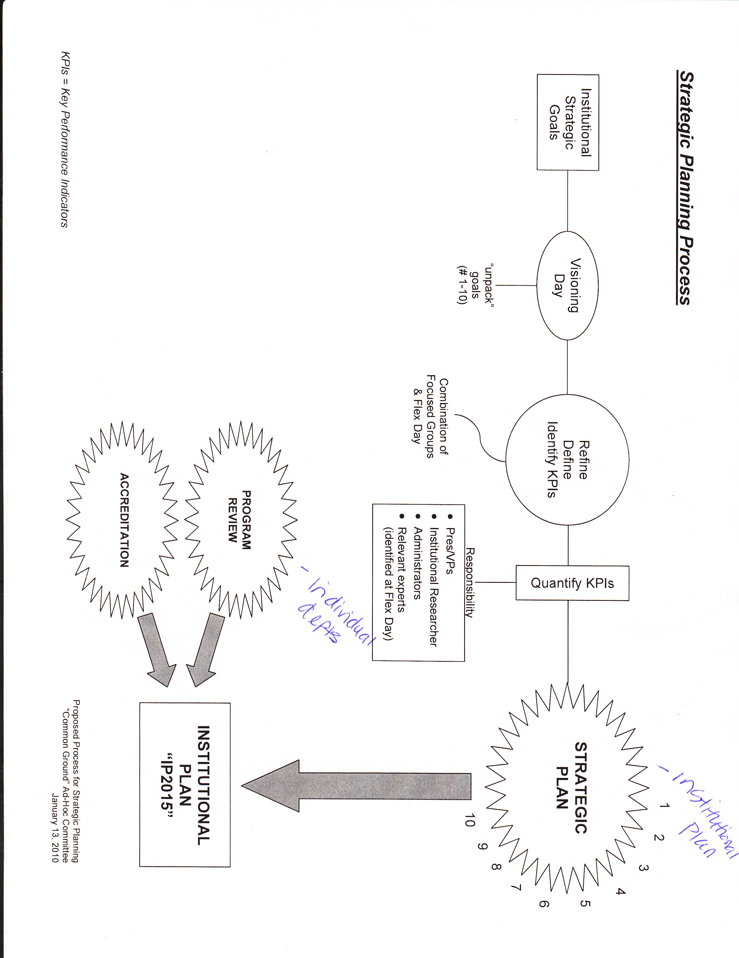

Attachment #2

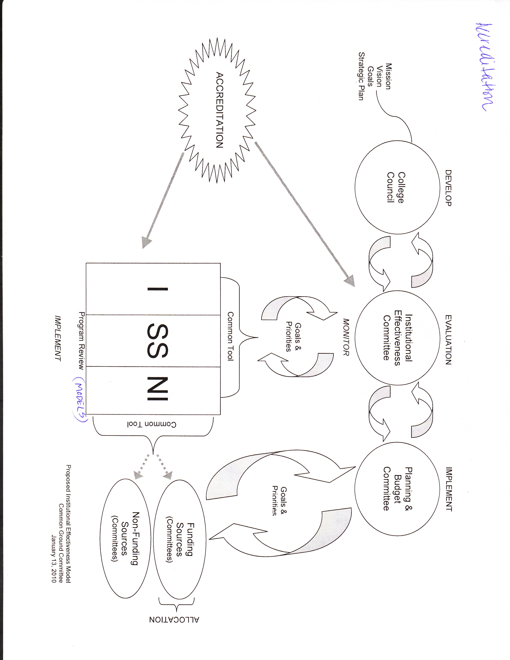

Attachment #3
