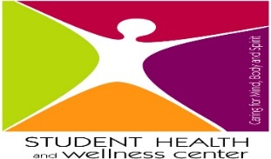

Emergencies: 911
Planned Parenthood: 1-800-230-7526
National Suicide Prevention: 24 Hour Hotline 1-800-273-8255
Therapist search: https://www.psychologytoday.com/
Dental: www.denti-cal.ca.gov

Alameda County Medical Services
Mental Health Referral Center: ACCESS PROGRAM: 1-800-491-9099
Axis Community Health: 925-462-1755
Highland Hospital Emergency Room: 510-437-4800

Contra Costa Medical Services
Mental Health Referral Center: ACCESS PROGRAM: 1-888-678-7277
Concord Health Center: 925-681-4100
Contra Costa Regional Medical Center Emergency Room: 925-370-5000

San Joaquin Medical Services
Mental Health Referral Center: ACCESS PROGRAM: 1-209-468-9370
Community Medical Centers: 209-636-5400
San Joaquin General Hospital Urgent Emergency Room: 209-468-6000

