APPROVED 3/25/10
LAS POSITAS COLLEGE
CLASSIFIED SENATE

JANUARY 28, 2010

2:30 P.M., ROOM 1603

MINUTES

Present: Cindy Balero, Rita Carson, Sharon Davidson, William Eddy, Sharon Gach, Natasha Lang, Carmen McCauley, Elizabeth Noyes, Karin Rose, Jeff Sperry, Todd Steffan, Heidi Ulrech, Christie Verarde

Guest: Jim Gioia

1. Welcome/Call to Order:

The meeting was called to order at 2:40 p.m. Quorum was met. Ms. Lang welcomed everyone and thanked them for taking the time to attend the meeting.

2. Introduction of New Attendees & New Staff:

No items.

3. Approval of Agenda and Minutes:
The agenda was approved unanimously.

Ms. Verarde motioned to approve the December 18, 2009 minutes as written; seconded by Ms. Rose. Motion carried with one abstention.

4. Budget:
Additional profits totaling $432.35 was collected.

Total social account balance is: $957.33
Training account balance is: $821.00
Additional Staff Development funds for Flex Day: $2,000.00

- Committee Reports:
  - January President’s Report: Refer to written report (attached)

  - Classified Senate Committees:
    - Activities Committee/Flex Day Plans (N. Lang/C. Balero): Several topics/themes have emerged:
- “Hidden Gems of LPC”
- TLC (formerly the Innovation Center)
- Facilities up and coming, tours, Mr. Kratochvil invited to speak.
- Budget discussion and open forum with Dr. Pollard
- Bocce ball (late afternoon)

The overall goal is to plan a day in which opportunities at all levels are made available. A subcommittee is still needed to work on coordination of events, etc. Mr. Eddy volunteered; however, additional support is still needed. Ms. Gach indicated she will send out an email soliciting interest and report back at the next meeting.

    - Sunshine Report (C. Reding/N. Lang): A card has been sent to Scott Vigallon and Ann Jones. A brief history of the fund and expenditure process was discussed.

    - Fundraising:
      - Candy Sales (C. Verarde): A candy box was purchased from Costco. It has been sold, totaling $24.00. Each candy bar is being sold for $1.00. Two (2) additional boxes will be purchased and located at Ms. Verarde’s desk. The goal is to sell $100.00 total.
      - Swap Meet for Staff/Students (W. Eddy): Approval is being sought for a location on campus to host the event. It will more than likely be held on a Friday. It will mirror the previous silent auction minus bidding. It is possible it will be held on a date after spring break. Volunteers are need and more information is to come. Contact William Eddy for more information. The possibility of including a BBQ was discussed.

- Old Business:
  - SEIU Update - None

  - Scholarships 2010 – How many $100 scholarships to award: A brief discussion occurred regarding the funding and amount of scholarships. Initially it was suggested six (6) be funded; however, everyone was reminded of the cost for the Outstanding Classified Award, which is approximately $300.00. Last year $500.00 was funded ($100 each). Ms. Lang noted she would like to confer with Ms. Shreibman regarding the criteria. It was noted Bookstore giftcards are appreciated by students. In conclusion it was determined the same amount as the previous year will be set aside for the scholarships. (5 at $100 each) due to the tight economic time/budget. It is hoped this can be increased in the future.

Ms. Ulrech motioned to approve five (5) $100 each Classified Senate Scholarship Gift Cards to the LPC Bookstore; seconded by Ms. Verarde. Motion passed unanimously.

    - Update on Strategic Visioning Process/Common Ground Subcommittee (Attachments #1, 2, 3): Natasha explained the three documents that came out of the Common Ground Subcommittee’s work. She was on the Subcommittee, and said they went into much detail about how all college processes should relate to each other. The Common Ground Subcommittee major highlights were the agreements:
- New models for Strategic Planning process, Institutional Planning process, and Institutional Effectiveness model.
- New timeline for planning process (through Fall 2010)
- March 12th Flex Day as a continuation of the Strategic Planning process and to identify the Key Project Indicators (KPIs)
- Develop a Common Tool for Program Review in the Spring, using the same model as the “Common Ground” group.

Mr. Eddy motioned to approve the work of the Common Ground Subcommittee as discussed and presented today; seconded by Ms. Noyes. Motion carried unanimously.

  - Outstanding Classified of the Year – Revision and History: Sharon Gach reported she is working with Debbie Earney and will be distributing revisions shortly. Ms. Earney would like to move onto other projects. It was proposed it be given a more formal “permanent home” in the Bylaws; where the committee structure can be “tightened up” and ownership taken. Ms. Gach requested this be an agenda item at the next meeting.

- New Business
  - Opening for VP of Fundraising: Everyone was encouraged to solicit anyone interested in filling this position. Contact Ms. Lang for more information.

  - Bylaws Review and Discussion: Due to the nature of the discussion of this topic, it was requested it be moved to the February/March meeting so as to allow for more discussion time. One item for consideration for addition into the Bylaws is how language should be stated/constructed for new staff/new hires and IT staff moving here, since the college is growing. What reporting/funding mechanisms
should be included? It was noted the current language “assigned to” is intentionally vague. More clarification is needed; additionally, concerns were raised regarding voting; specifically regarding concise, clear language. Bargaining unit concerns should remain separate. Ms. Lang noted the Bylaws should be “inclusive of what we mean.” In closing, Ms. Ulrech commented on the historical drafting and re-drafting of the document, reminding all it is a tedious project to undertake to revise them.

8. Other
Everyone was reminded Granlibakken is coming up in June. We are eligible for three (3) spots. Anyone interested in attending will need to have the forms submitted by February 26th and let Ms. Lang or Ms. Gach know as soon as possible.

- Good of the Order
No items.

- Adjournment
The meeting adjourned at 4:20 P.M.

Recording Secretaries:

Carie Kincaid / Natasha Lang / Sharon Gach

Attachment #1

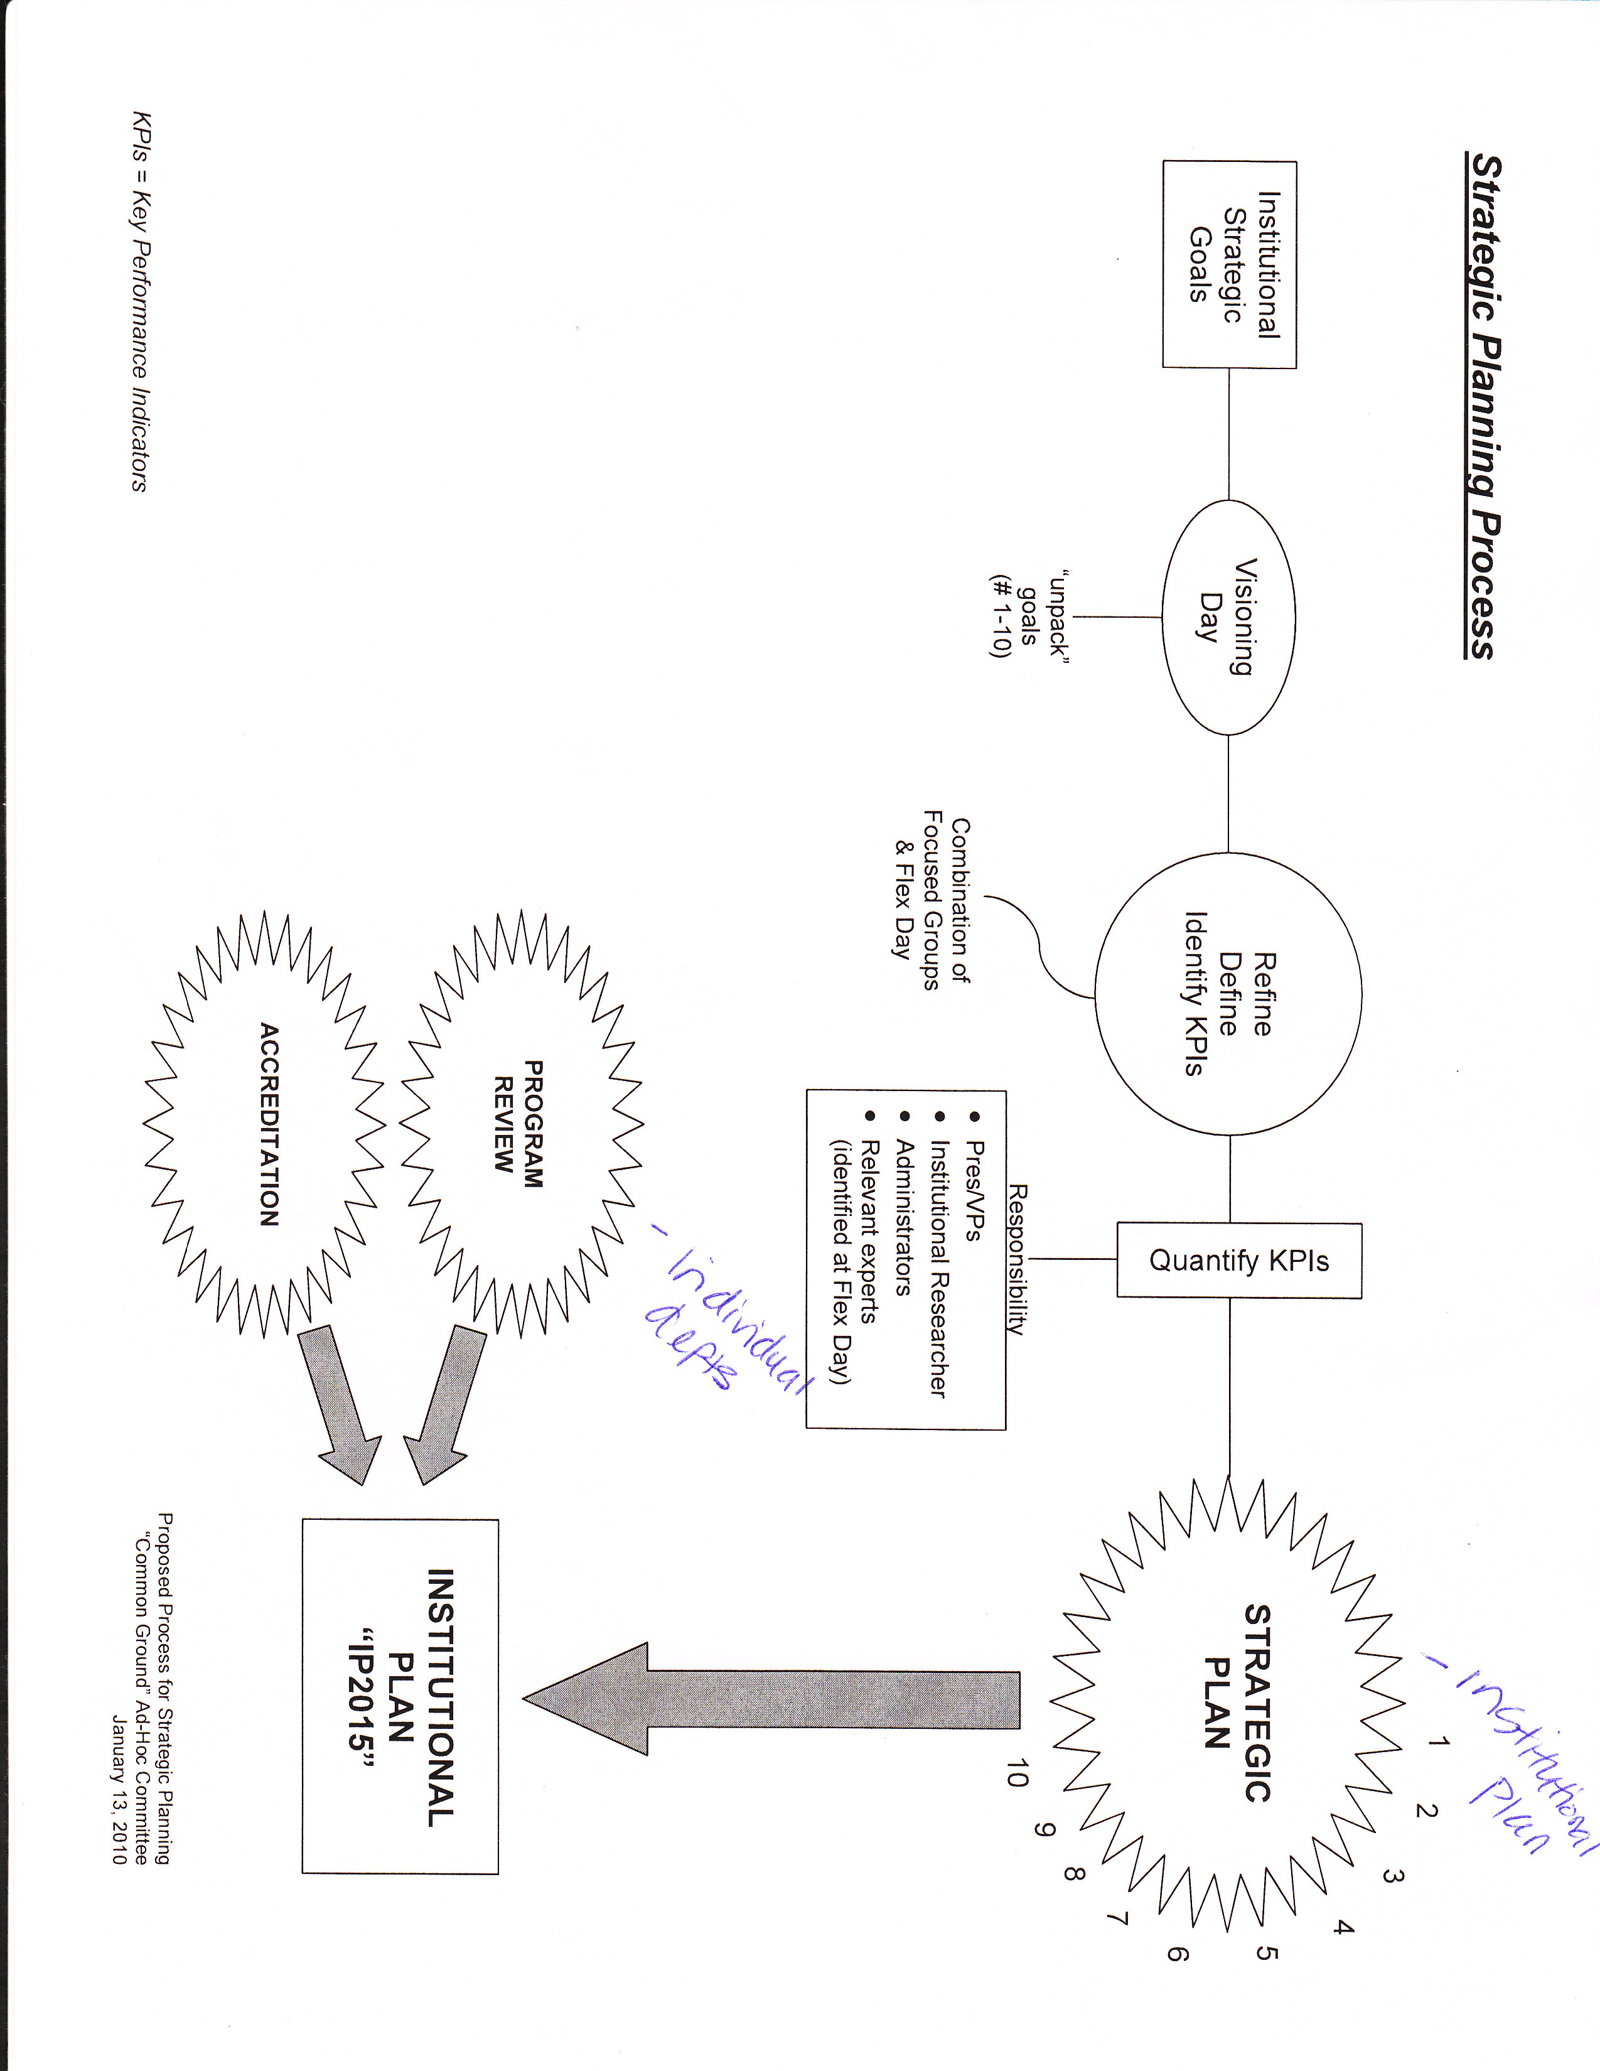

Attachment #2

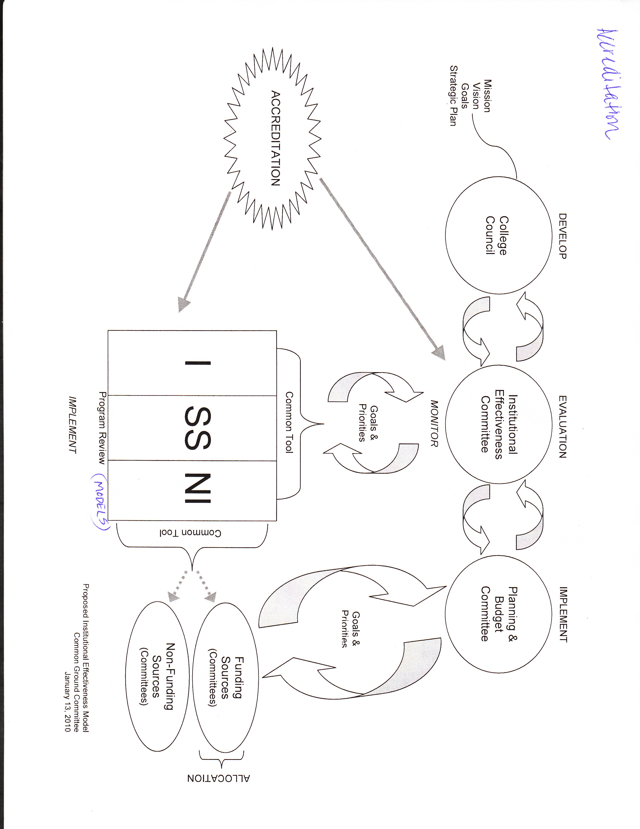

Attachment #3
